1. INTRODUCTION

AgarDown.io is a multiplayer action game. It is a simpler implementation of the game Agario thus the ‘Down’ in its name.

* 1. Rules

The game requires at least 3 players to start the game. The initial state will be an area littered with “food” for the circle. Eating each “food” will make the circles bigger. The objective of the game is to destroy other circles to survive the game.

* 1. Game Requirements
     1. Operating System: Linux – Ubuntu, Windows OS, or OS x El Capitan
     2. Java SDK (version 1.8)
     3. (Optional) Eclipse IDE
  2. Compiling and Running
     1. Using the Command Line
        1. Compile:
        2. Run:
     2. Using IDE:

Click ‘Run as’ and choose ‘Java Application’.

1. USING THE GAME
   1. Terminology
      1. Food – these are the dots littered on the game window. The circles will eat them to get bigger.
      2. Eat – colliding with either the food or the circles.
      3. Circle/s – each circle represent a player. Each of them has a name attached on them.
   2. User Interface

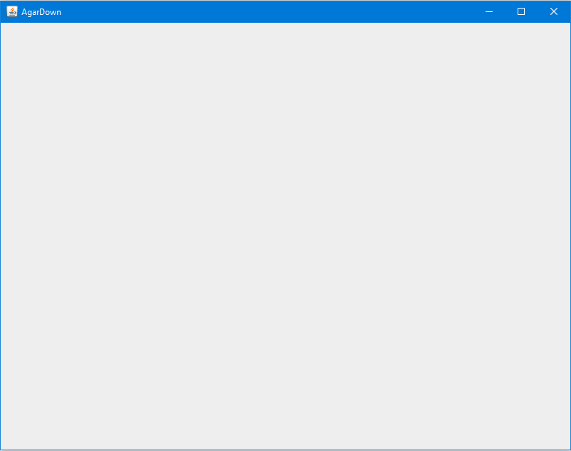

Figure 1. Server GUI

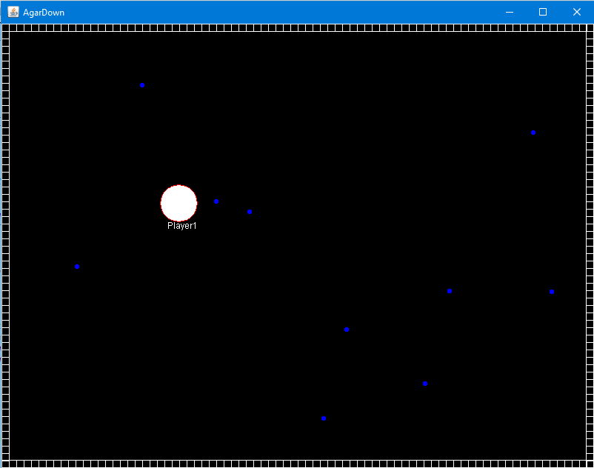

Figure 2. Client/Player GUI

1. HOW TO PLAY
   1. Start a New Game

After running the game, the user will be asked to input his/her username.



Figure 3. Username Prompt

The user will then be asked to choose between being the server or the client.



Figure 4. Server Prompt

If the user chose server, the program will prompt the user to input the number of players.



Figure 5. Number of Players Prompt

Both type of users will be asked to input the server address.



Figure 6. Server Address Prompt

Once the required data and the required number of users are acquired, the game will start.

* 1. How to Play a Game

There is only one type of circle, an attacker. The circles will attack each other by “eating” them. This action will result to gaining points for each circle they “eat”.

* 1. Winning

There is a time limit of two minutes. Once the time limit is reached, the game will end. The ranking will be listed and the winner will be the circle with highest score or the last remaining circle.